Image Processing with ImageJ Exercises

Using the information in the ImageJ Tutorials and the built-in ImageJ Command Finder tool (open ImageJ / Fiji and type L to get it to pop up), complete the following exercises. You may not be able to complete these exercises in the time you have, but do your best.

Exercise 1

Use the cd31 glomeruli.tif file to create the montage shown below. The image comes as two images grouped together in a stack, so your first job is to figure out how to separate them. The pixel size for the image is 0.25 microns. Don’t forget the 20um scale bar in the lower right hand corner!

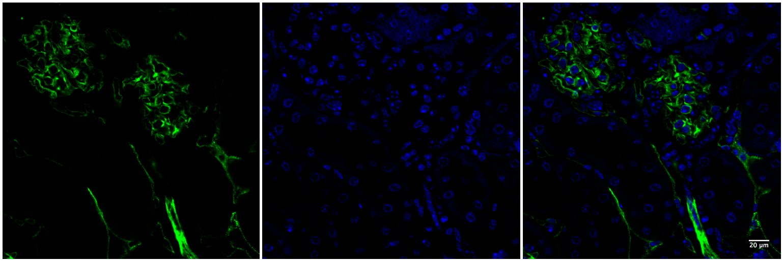

Exercise 2

Use the pancreatic_islet.tif to answer the following questions:

1. 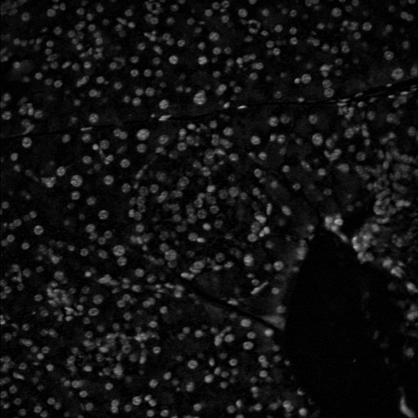How many cells are in the entire image? One nucleus per cell is marked by the DAPI stain in the first image.
2. What is the average nuclear area for all the cells in the image? Readout should be in um2 NOT cm2!
3. How would you create a data table that includes the mean gray value for every nucleus in the image? They are not all 255!

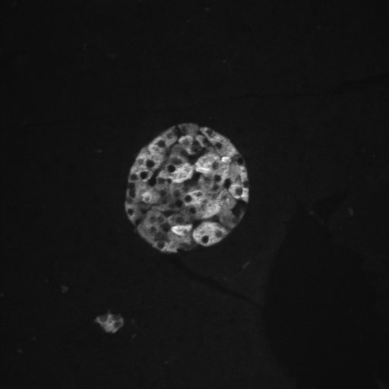

1. How many beta cells are in the image? Beta cells are represented by the insulin (green) stain in the second image. Hint: you can still count the nuclei if you find a way to restrict your count to nuclei in an islet.

Bonus Questions (if you have time)

Bonus 1: if there were multiple islets in the pancreatic_islet.tif image, how could you count the number of cells PER islet?

Bonus 2: Create a macro to automate the creation of the cd31 glomeruli montage.